**St Ambrose College**

**Computer Science**

**Year 8**

**Python Unit**



Chimaobi Soronnadi

**Name:**

8D

**Class:**

S1

**Target:**

**Final Grade:**

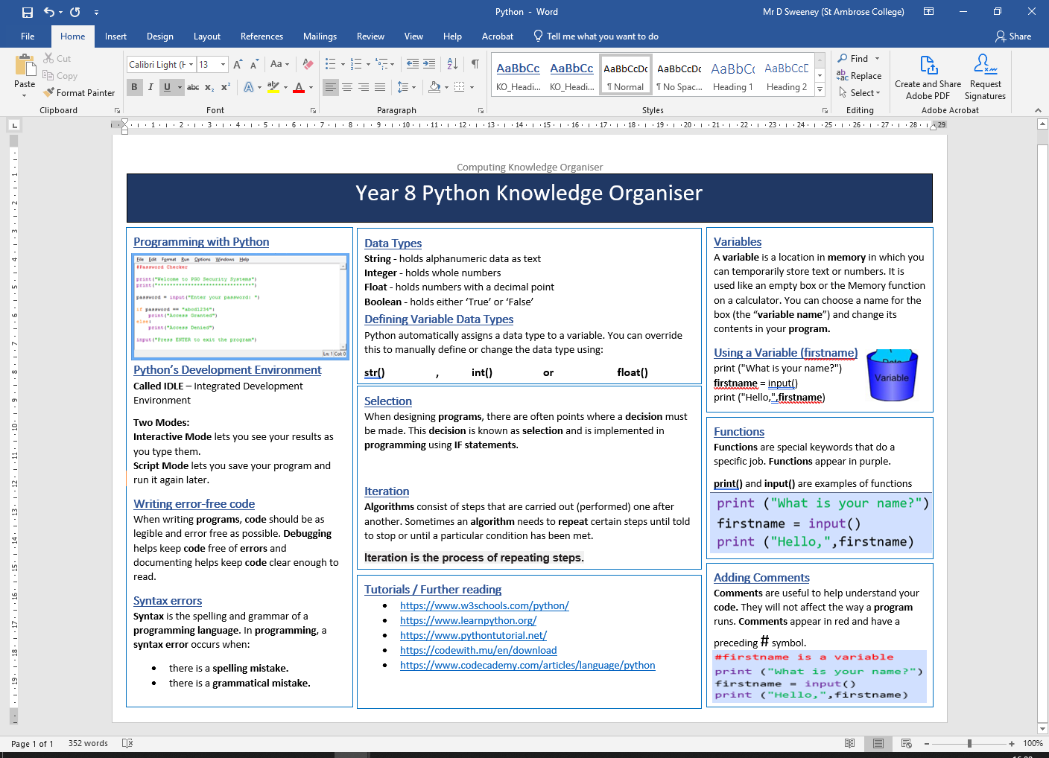

**LESSON ONE – INTRO TO PYTHON**

* LO1 - Create simple code including the input and print scripts.
* LO2 - Create variables and declare the data types for variables.

**Task One: Print screen the code you produced to complete the tasks below and paste it into the box below. You should also include a print screen of the code running.**

* Write a program that outputs todays date.
* Write a program that outputs your full name
* Write a program that outputs the name of your favourite sport or hobby
* Write a program that outputs the names of your family, Each name should be displayed on a different line

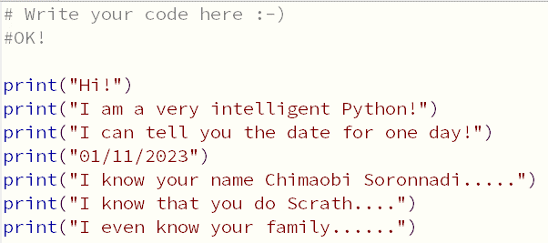

**Task Two: Print screen the code you produced to complete the tasks below and paste it into the box below. You should also include a print screen of the code running.**

* Ask for their age and output in a sentence
* Ask for the team they support and output it in a sentence.
* Ask for favourite film and output in a sentence
* Ask who favourite actor/actress is and output in a sentence

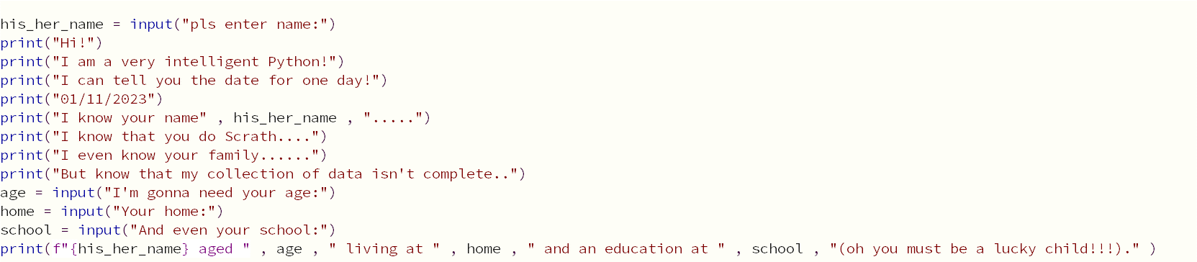

**LESSON TWO – INPUTS**

* LO1: Create simple code including the input and print scripts.
* LO2: Create variables and declare the data types for variables.

**Starter: Spot the errors in the python code and rewrite the code to correct the mistakes.**

1. Name = Input(‘What is your name?’)

Name = input(‘What is your name?’)

1. a == (input('Enter number 1:'))

a = input('Enter number 1:')

1. name=input('What is your name?')

print('Hello ' name)

Name = input('What is your name?')

print('Hello ' , name)

1. a = int(input('Enter number 1:'))

d = int(input('Enter number 2:'))

c=a+b

PRINT('Adding your numbers together gives:'+c)

a = int(input('Enter number 1:'))

b = int(input('Enter number 2:'))

c = a+b

print ('Adding your numbers together gives:' , c)

**Task One: Print screen the code you produced to complete the tasks below and paste it into the box below. You should also include a print screen of the code running.**

Today’s Task is to create your first full computer program in Python. You are going to create a program that has the following requirements:

* Asks the user for their name
* Welcome the user to the program
* Asks the user for the day
* Ask the user for the date
* Ask user for month
* Ask user for year
* Asks the user for their age
* Asks the user for their best friend’s name
* Asks user for their favourite song
* Asks user for the artist that sings that song
* Askers the user for a hobby
* Asks the user what they want to be when they grow up
* Outputs the information supplied like the text below…

***NAMEOFUSER****, today is* ***Monday******25******December******2019*** *and you are* ***12*** *years old and your best friend is called* ***NAME****.*

*Your favourite song is* ***SONGNAME*** *and this is sung by* ***ARTIST*** *and* ***NAMEOFUSER****, I believe your favourite hobby is* ***HOBBYNAME*** *and that you want to be a* ***CAREER***

**PASTE YOUR CODE INTO THE SPACE PROVIDED ON THE NEXT PAGE**

**EXTENSION**

* Ask any further questions and output them into full sentences.
* Complete the ‘1. Extension tasks for Inputs’ document found in the extension folder on shared area

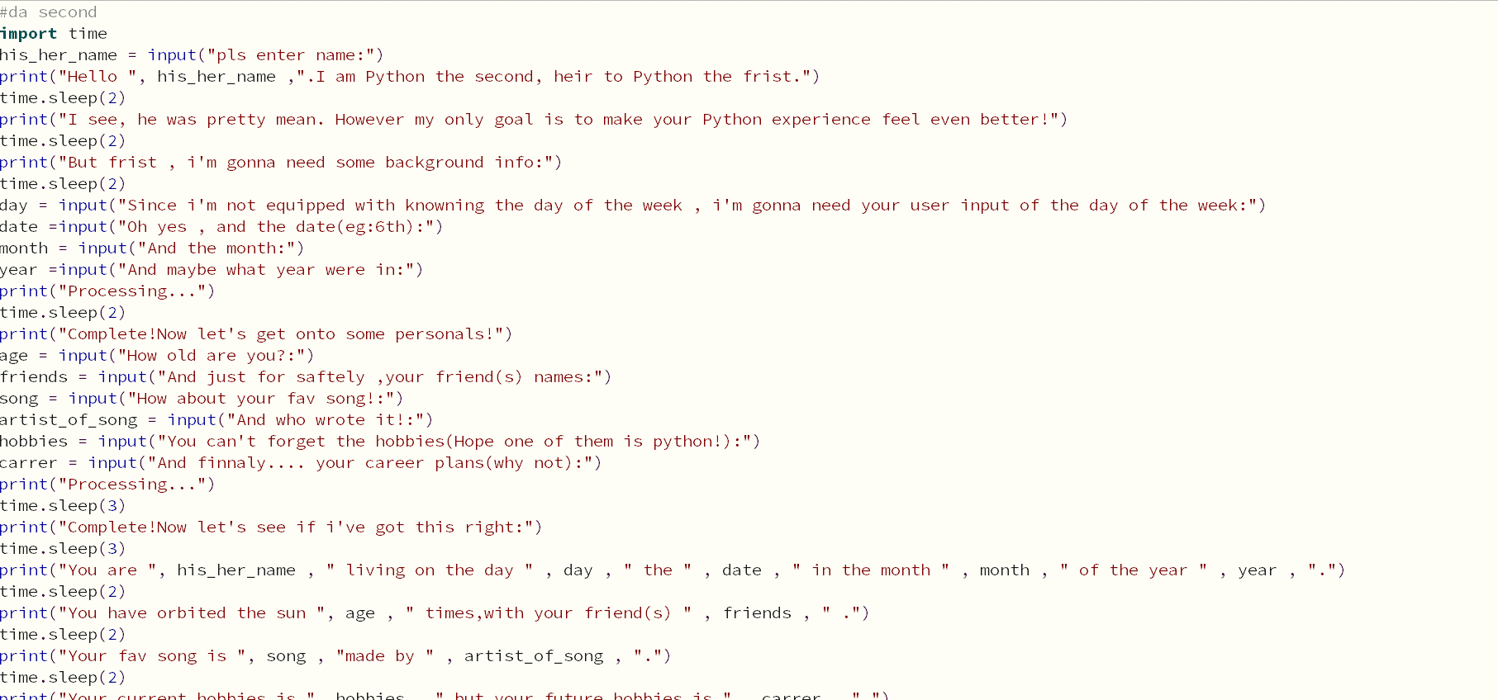

**LESSON THREE - INTEGERS**

* LO1 – Be able to declare the data types for variables.
* LO2 – Use integers and operators to complete calculations

**Task One: Complete the table below.**

|  |  |
| --- | --- |
| **Operator** | **What it means** |
| **+** | **Plus : Adds two integers or joins two strings** |
| **-** | **Minus: Subtracts two integers or separate a string** |
| **\*** | **Times: Multiplies two integers or doubles a string** |
| **/** | **Divide: Divides two integers or halves a string** |
| **//** | **N/A** |
| **%** | **N/A** |

**Task Two: Print screen the code you produced to complete the tasks below and paste it into the box below. You should also include a print screen of the code running.**

1. Write a program that will ask the user for three integer numbers and then add these numbers together before displaying the answer. The input and output should be user friendly.

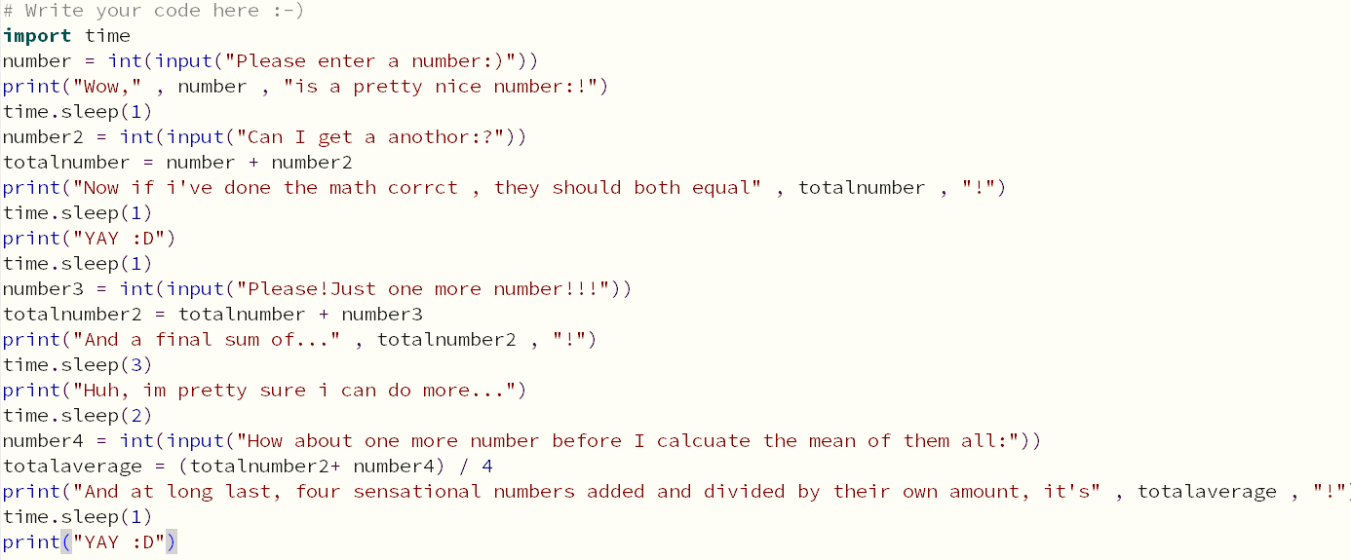

1. Write a program that will ask the user for four integer numbers and then add them together and then divide that total by 4 to show the average. The input and output should be user friendly.



1. Write a program that will ask for the total bill at the restaurant and then the number of diners who ate that meal. It will then work out how much each person should pay for an equal share of the meal.
2. Write a program that will ask the user the height and then the width of a rectangle and which will then show the area of the rectangle.
3. Alter the previous program so that it will ask for the height, width and also the depth of a box and then show the total volume of that box.
4. Write a program which will ask for the height, width and depth of a small box and then the height, width and depth of a larger box. Work out how much space is remaining around the small box when it is placed inside the bigger box.

**Extension: Complete the ‘plenary activity’ document in the lesson 3 folder**

**LESSON FOUR – IF STATEMENTS**

* LO1 – Understand the term Selection
* LO2 – Know what an IF statement does
* LO3 – Make use of IF statements in your programs

**Task One: Print screen the code you produced to complete the tasks below and paste it into the box below.**

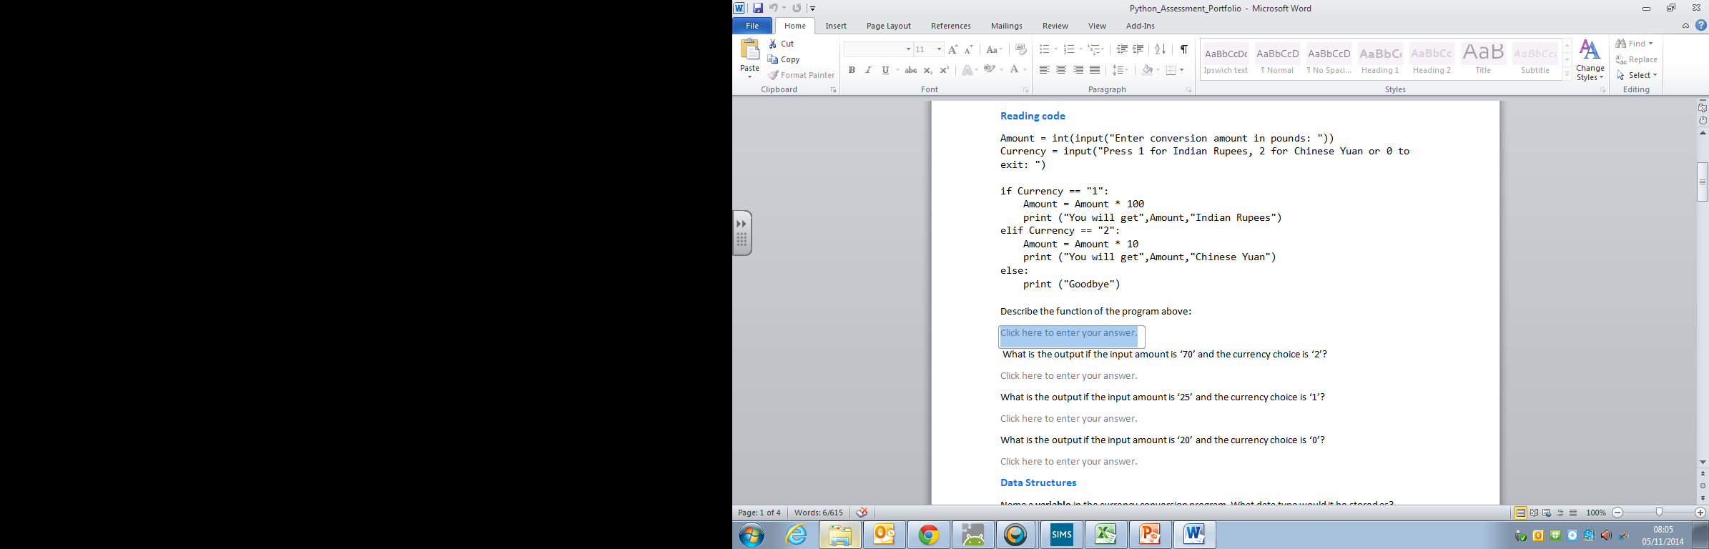

* Write out the code above and then add code and conversion rates for the following:
  + Euros
  + US Dollars
  + Australian Dollar
* ***Use XE.com to find out the real conversion rates***

**PASTE YOUR CODE INTO THE SPACE PROVIDED ON THE NEXT PAGE**

**Task Two: Print screen the code you produced to complete the tasks below and paste it into the box below.**

The height boards in Alton Towers are being stolen and have graffiti all over them

So, Alton Towers are changing to a computerised system of letting people know if they can get on rides. They want you to create a program that:

* Asks the user for their name and welcomes them to the theme park
* Asks them for their height in cm
* If they are over 100cm in height a message should be displayed saying
  + Username congratulations you are tall enough to go on all the rides
* If the user is under this height then a message should say:
  + Username sorry you are not allowed on the rides due to your height.

**Extension**

* If the user is between 50cm and 99cm in height then a message should say:
  + Username, you are allowed on the child only rides due to your height.

**Extension Activity: Complete the IF statements extension tasks that can be found in the extensions folder.**

**LESSON FIVE – IF STATEMENTS: PART 2**

* LO1 –Make use of IF, ELIF and ELSE statements in your programs

**Task One: Print screen the code you produced to complete the tasks below and paste it into the box below. You should also include a print screen of the code running.**

1. Write a program that will ask the user to input a number between 50 and 60. If the user enter a number between 50 and 60 it will respond saying “your number is within range”. If it is outside of the range it will say the number is either “too high” or “too low” depending on what was entered.

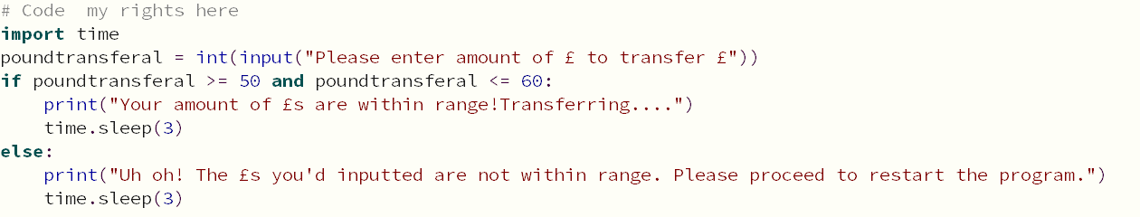

1. Customers in a bank want to find out if they are overdrawn or not. Ask the user to enter how much money they have and then tell the user if they are overdrawn or not. They are overdrawn if their balance is below 0.

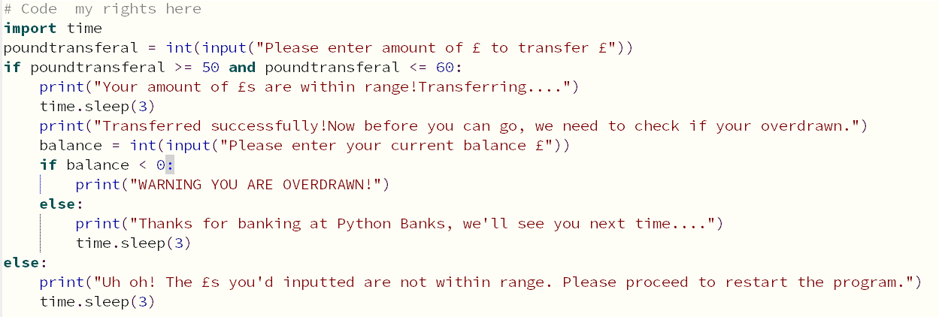

1. Create a system that allows a student to enter what house they are in and it will tell them which day their assembly is on. AQ= Monday, AU=Tuesday, IG=Thursday and NE= Friday

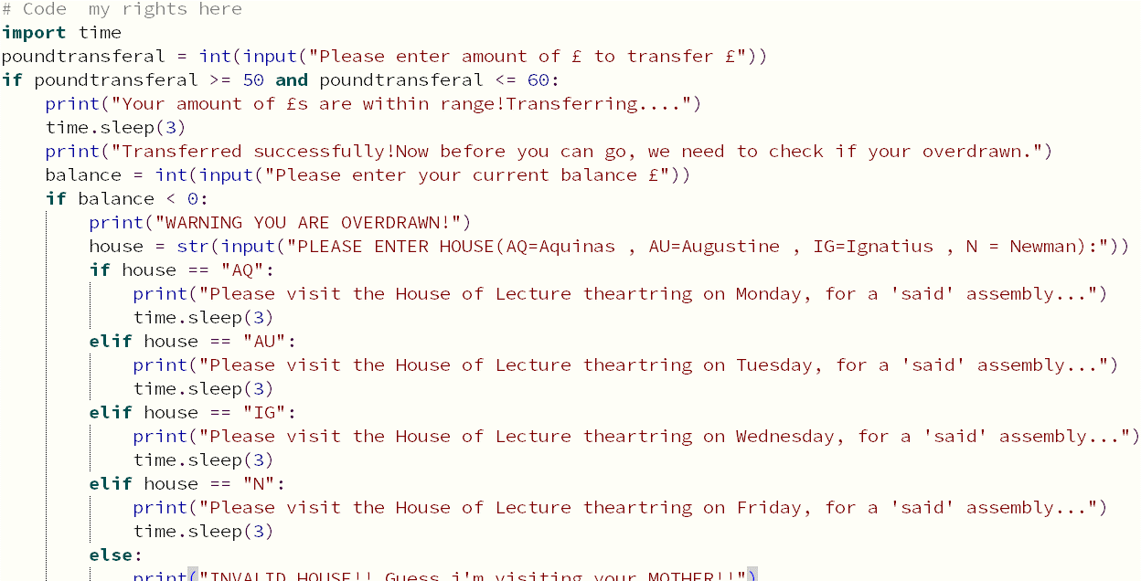

1. Write a program which will ask the user to enter the amount of goals Manchester United scored and how many goals Manchester City scored. It should then calculate which team won and say how many points each team will get (3 points for a win, 1 for a draw and 0 if they lose).
2. Create a program which will ask the user to enter the number of questions in a test and also the number the student scored in that test. It should work out the percentage they scored. For instance if the student got 12 correct out of 20 then they scored 60%. It should also work out if they passed the test and show a suitable message if they got 50% or more in the test and a different message telling them they failed the test if they scored under 50%.
3. Create a system whereby you can enter a number between 1 and 10 and it will tell you what element it represents.

See <http://www.ptable.com/Images/periodic%20table.png>

**LESSON SIX - LOOPS**

* LO1 – Understand what a loop is used for when programming
* LO2 – Be able to make use of the WHILE statement

**Task One: Print screen the code you produced to complete the tasks below and paste it into the box below. You should also include a print screen of the code running.**

1. Write a program that outputs the numbers 1 to 500

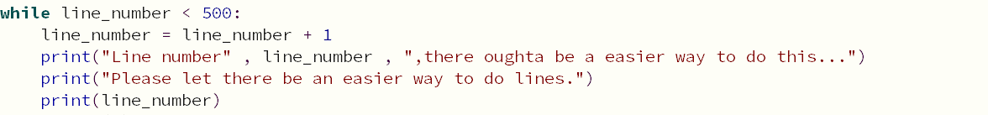

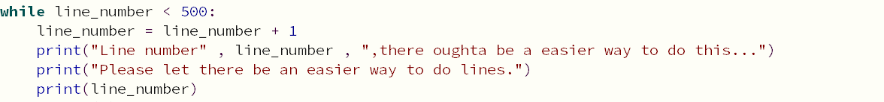

1. Write a program that outputs the numbers 1 to 500 going up in 10’s each time

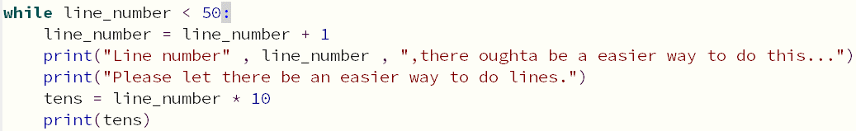

1. Write a program that repeats the following phrase 100 times; *"is it the end of the school day yet"*.

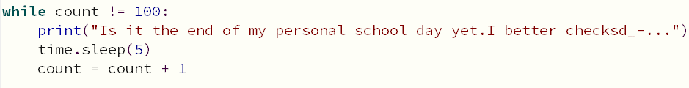

1. Write a program that outputs *"is it the end of the school day yet"* 50 times and include the number in the sentence



1. Write a program that asks the user to enter a name. If the name entered doesn’t match your name then the system should ask the user again
2. Write a program that allows a user to input an integer, and then repeats the phrase *"is it the end of the school day yet"* the specified number of times using a while loop.
3. Write a program that asks a user to input a number, adds this number to a 'current total' (initially set to zero), and then outputs the current running total. The program should repeat this process and only exit when the current total exceeds 100.
4. Write a program that asks a user to input a number, subtracts this number from ‘money' (initially set to 100), and then outputs the current running money amount. The program should repeat this process and only exit when the current total gets to below 0. It should then say you have no money left.

**LESSON SEVEN – LOOPS RECAP**

* LO1 – Be able to make effective use of the WHILE statement

**Task One: Finish off the tasks from last lesson relating to loops.**

**Task Two: Pick any of the tasks below and create the code for that task.**

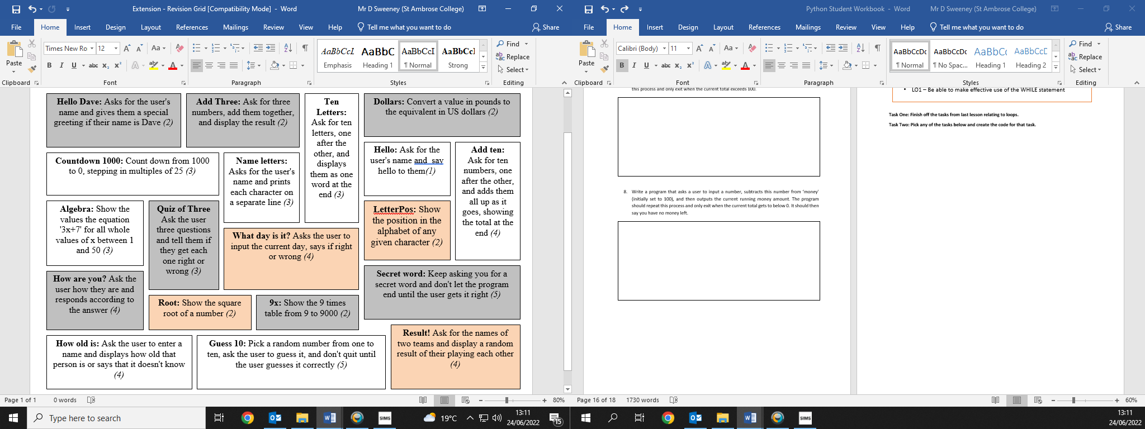

**EXTENSIONS FOR ANY LESSON**

**Go to the extension folder in the Python area and work your way through any of the extension tasks.**

**PYTHON TEST CODE**

**LESSON 7 - HOMEWORK**

* Print out the booklet
* Revise for the end of topic test next lesson
* The test will cover everything within this booklet
* Use the

**PYTHON TEST CODE – IMPROVEMENTS**